# NOISE POLLUTION MONITORING

Project Definition:

The project involves deploying IoT sensors to measure noise pollution in public areas and providing real-time noise level data accessible to the public through a platform or mobile app.

The primary objective is to raise awareness about noise pollution and enable informed decision-making. This project includes defining objectives, designing the IoT sensor system, developing the noise pollution information platform, and integrating them using iot

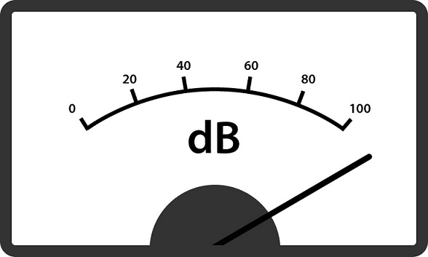

# PROBLEM DEFINITION:

# ****Noise pollution****, unwanted or excessive [sound](https://www.britannica.com/science/sound-physics) that can have [deleterious](https://www.merriam-webster.com/dictionary/deleterious) effects on human health, wildlife, and environmental quality. Noise [pollution](https://www.britannica.com/science/pollution-environment) is commonly generated inside many industrial facilities and some other workplaces, but it also comes from highway, railway, and airplane traffic and from outdoor construction activities.

# DESIGN THINKING:

Noise pollution in metro cities is a growing concern as it is slowly affecting our body and mind. Loud noises can cause ear discomfort, such as ear ringing, ear pains and hearing loss, etc. Noises above 115db can even lead to deafness. According to statistics, about 50 percent of those who are exposed to the noise above 80db for a long time lose their hearing

Noise or sound level monitoring or measurement is a process to measure the magnitude of Noise in industries and residential area. Data collected from Noise level monitoring & Testing helps us to understand trends and action can be taken to reduce noise pollution

# IOT SENSORS’S DESIGN:

System keeps measuring sound level and reports it to the online server over IOT. The sensors interact with microcontroller which processes this data and transmits it over internet.

For the hardware parts, LM 393 sound sensor is used to read the readings of the sound level from the environment. The reading of sound sensor is calibrated using the real sound level meter to ge t the accurate readings of the sound level. The 16x2 LCD will show the values of sound level at that researched area and give the warning that says the level of sound is high when the measurement exceeds the set value. If the users could not read the readings due to poor eyesight, they can know the level of sound by using the light emitting diodes (LED) which in red, blue and green colour placed below the LCD. LED acts as an indicator to indicate when the noise is very high. It will turn to red, blue for low noise while green for intermediate level. All these components such as sound sensor, LCD, and LEDs will be connected to the ESP8266

The sound sensor will record the readings of sound level at the researched area. Then, the data is sent over to the cloud server called Firebase. Firebase is a development platform that is specialized for web application and mobile developed by Firebase Incorporation [15]. Firebase is chosen as the cloud server for this system because it can easily be connected to Android Studio. The data is stored in Firebase real-time database which the user can also access via web browser. Then, data from Firebase is transferred to the app. The users can use the app to know the reading of sound level and they also can know which time is suitable to study and what factors contribute to the high noise based on the value of sound level.

# 